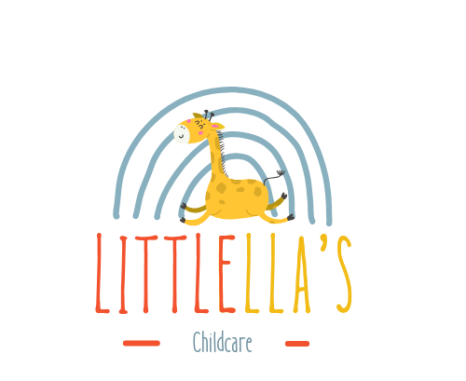

Anti-Bullying Policy

Littlella’s Childcare is committed to providing a safe, nurturing and inclusive environment for all children and their families. As part of our practice, we maintain regular communication with parents and carers through:
- Tapestry memos to share essential information, updates and changes within the nursery
- Email correspondence regarding important notices, updates and available services
- Daily updates on children’s routines, learning and development progress

Purpose of this Policy
This policy aims to:
- Prevent bullying between children attending our setting or taking part in associated activities
- Ensure that any bullying is identified and addressed promptly, with appropriate support offered to all parties involved
- Provide clear guidance for staff, volunteers, children and families on how bullying can be prevented, recognised and effectively managed

Definition of Bullying
Bullying refers to behaviour—repeated or intended—that causes harm, distress or discomfort to another individual, whether physically, emotionally or socially. This may include verbal, physical, relational or online bullying.

Our Commitment
We believe that:
- All children have the right to feel safe, valued and free from any form of abuse or harm
- It is our responsibility to promote children’s wellbeing, safeguard their welfare and act in a manner that protects them at all times
We recognise that:
- Bullying can have significant, long-lasting impacts on a child’s health, confidence and development
- Any form of bullying has the potential to cause serious harm
- Every child—regardless of age, disability, gender reassignment, race, religion or belief, sex, or sexual orientation—deserves equal protection from harm
- Everyone within our community has a role in recognising, preventing and challenging bullying behaviour, including online harassment

Preventing Bullying
To promote a positive and respectful culture, we will:
- Implement a clear code of conduct outlining expectations for behaviour within the nursery, including online interactions
- Engage staff, volunteers, children and families in regular discussions regarding positive relationships, respect and the prevention of bullying
- Provide ongoing training and professional development for staff and volunteers on identifying and responding to all forms of bullying, including discriminatory or prejudice-based bullying
- Maintain robust anti-bullying procedures as part of our safeguarding framework
Promoting Positive Relationships
Our routine discussions and activities will support children and adults to:
- Understand their shared responsibility to uphold our behaviour expectations
- Develop skills such as active listening, empathy and emotional regulation
- Celebrate and respect individual differences within our nursery community
- Foster friendships and ensure no child feels isolated
- Approach challenges and conflicts in constructive, solution-focused ways
- Reflect on the effectiveness of our anti-bullying measures and make improvements where needed
Responding to Bullying Concerns
When managing incidents of bullying, we will carefully consider:
- The needs and wellbeing of the child experiencing bullying
- The needs and circumstances of the child displaying bullying behaviour
- The impact on any witnesses or bystanders
- The implications for the wider setting
A clear action plan will be developed for each incident and reviewed regularly to ensure the resolution is effective and sustained long-term.
Diversity and Inclusion
Bullying often arises from a lack of understanding or acceptance of difference. At Littlella’s Childcare, we are committed to:
- Promoting an inclusive culture that celebrates diversity and encourages mutual respect
- Providing opportunities for children to learn about and appreciate different backgrounds, cultures and experiences
- Welcoming and valuing all families, staff and volunteers within our community
- Actively increasing diversity within our team and the families we serve where possible
Further Information
Guidance on recognising and responding to bullying can be found through national safeguarding resources, including:
- Protecting children from bullying and cyberbullying
- Recognising and responding to abuse

Policy Adoption and Review
This policy was adopted by: LittlEllas Childcare
On: 01/01/2026
Date to be reviewed: 01/01/2027
Name and role of signatory: Samba Matundu (Nursery Manager)

