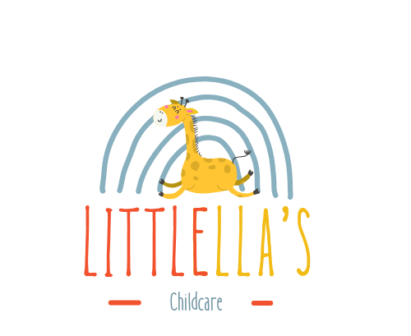

Online Safety
Link to Every Child Matters: Feeling Safe
Links to Safeguarding and Welfare Requirements: 3.4-3.7
At LittlEllas Childcare, we recognize the growing role of the internet in daily life and its benefits. However, we remain vigilant about its potential dangers and are committed to supporting children, staff, and families in using the internet safely.
Online Safety Risks
The Keeping Children Safe in Education framework identifies three key online risks:
- Content: Exposure to illegal, inappropriate, or harmful material.
- Contact: Harmful interactions with other users.
- Conduct: Personal online behavior that may cause harm.
Our Designated Safeguarding Person (DSP), Samba Matundu, is responsible for addressing online safety concerns. All concerns should be reported to her promptly.
Steps to Ensure Online Safety
Within the nursery, we take the following measures to protect children and staff online:
- Using updated antivirus and anti-spyware software on all devices.
- Implementing content blockers and filters on all nursery devices.
- Safeguarding passwords using a secure password management program.
- Monitoring all internet activities in the setting.
- Locking away nursery devices when not in use.
- Ensuring nursery devices cannot install social media or messaging apps.
- Reviewing all apps or games for age-appropriateness and safety.
- Prohibiting personal or financial information sharing via email.
- Supervising children when using internet-enabled devices.
- Using tracking software to monitor older children's internet activity.
- Restricting staff and visitor access to the nursery Wi-Fi.
Educational Practices
- Teaching children online safety rules, including:
  - Only going online with adult supervision.
  - Being kind online and protecting personal information.
  - Reporting anything upsetting encountered online.
- Incorporating online safety into daily activities, such as discussing safe and unsafe online behaviors.
- Providing ongoing staff training on online safety and its importance in child safeguarding.
Device and Internet Usage
- Nursery computers are in visible areas and monitored by staff.
- Children are not permitted unsupervised internet access or use of email.
- Staff adhere to an acceptable use policy, ensuring nursery IT equipment is used solely for work purposes.
- Suspicious or offensive material is reported to the Internet Watch Foundation (IWF) or CEOP.
Social Media Policy
- Staff manage personal security settings and do not accept friend requests from parents/carers.
- Staff avoid discussing work-related issues on social media.
- Parents and visitors are asked not to post photos or information about children from the nursery online.
Online Learning and Data Security
- Staff use nursery devices to capture and store learning journey data securely.
Reporting Concerns
If online safety concerns arise, staff should follow the nursery’s safeguarding policy and report issues to the DSP. Staff and parents are encouraged to utilize resources such as the NSPCC and CEOP for guidance and support.
Resources and Guidance
- NSPCC: Keeping Children Safe Online Training
- CEOP: Child Exploitation and Online Protection Centre
- For further guidance: Safeguarding Children and Online Safety Considerations for Managers

Policy Adoption and Review
This policy was adopted by: LittlEllas Childcare
On: 01/01/2026
Date to be reviewed: 01/01/2027
Name and role of signatory: Samba Matundu (Nursery Manager)

