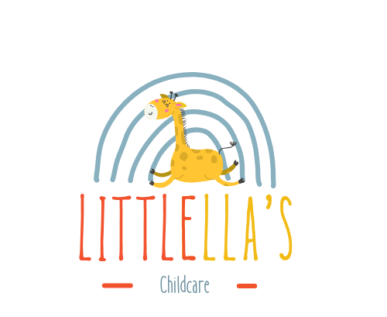

Whistle Blowing Policy and Procedure
Link to Every Child Matters: Feeling Safe
Links to Safeguarding and Welfare Requirements
At LittlEllas Childcare, we expect all colleagues, both internal and external, to maintain professionalism and prioritize the highest possible standards of welfare and safety for every child. In alignment with this commitment, we encourage parents, employees, and others to voice any serious concerns about any aspect of our operations. We ensure confidentiality in such cases and guarantee that employees can follow this policy without fear of reprisal.
This Whistle Blowing Policy is designed to encourage and enable employees to raise serious concerns internally instead of overlooking a problem or reporting it externally. All staff at LittlEllas Childcare have a responsibility to raise concerns about poor or insufficient practices, prioritizing children’s well-being and safety above loyalty to colleagues.
Policy Objectives
- Enable and encourage individuals to raise genuine and legitimate concerns.
- Support staff in addressing and eliminating poor or insufficient practices.
- Investigate any raised concerns confidentially and appropriately.
- Protect those raising concerns from retaliation or victimization.
We recognize that there may be occasions when staff need a procedure to report issues that suggest children’s welfare and safety may be at risk.
Legal Framework
This policy aligns with the Public Interest Disclosure Act 1998 (Whistleblowing Act), which protects employees who raise legitimate concerns about specific matters known as "qualifying disclosures."
A qualifying disclosure must be made in the public interest and can include:
- Criminal offenses.
- Risks to health and safety.
- Miscarriages of justice.
- Damage to the environment.
- Breaches of legal obligations (e.g., EYFS, Equalities Act 2010).
- Concealment of any of the above.
- Radicalized or national security threats.
- Any other unethical conduct.
Disclosures must be substantially true, not malicious, and not motivated by personal gain.
Disclosure Procedure
If, during employment, staff become aware of information suggesting children are at risk of danger or one of the qualifying concerns is occurring, they must act according to the nursery’s disclosure procedure:
- Report to the Line Manager: Concerns should first be raised with the line manager to address issues early. If the concern involves the line manager, staff should report to the Deputy Manager or the Designated Safeguarding Person (DSP).
- Alternative Contacts: If internal escalation is unsuitable, staff can contact external authorities such as the Local Authority Designated Officer (LADO), Ofsted, or the local authority children’s social care team.
- Written Records: Concerns are better raised in writing, detailing names, dates, times, and places where possible. If verbal disclosure occurs, the receiver will document the discussion and ask the complainant to confirm its accuracy.
- Investigation: Within one week of raising the concern, staff will receive written acknowledgment, and within two weeks, updates on the investigation’s progress. Upon completion, staff will be informed of the outcome.
Confidentiality
The identity of the whistleblower will be protected, but in certain situations, it may need to be disclosed. In such cases, the whistleblower will be informed beforehand.
Anonymous Complaints
While anonymous complaints are harder to investigate, they will still be reviewed where possible. Providing a name and written statement strengthens the investigation’s effectiveness.
Untrue or Malicious Allegations
No action will be taken against individuals raising concerns in good faith, even if unconfirmed. However, malicious or false allegations may result in disciplinary action.
Actions Not Allowed
Staff must not:
- Investigate matters independently.
- Approach or accuse individuals involved.
- Discuss concerns outside the designated channels.
Contact Details for Ofsted
If dissatisfied with the internal process, staff can elevate concerns to Ofsted:
- Hotline: 0300 123 3155 (Mon-Fri, 8 am–6 pm)
- Email: whistleblowing@ofsted.gov.uk

Policy Adoption and Review
This policy was adopted by: LittlEllas Childcare
On: 01/01/2026
Date to be reviewed: 01/01/2027
Name and role of signatory: Samba Matundu (Nursery Manager)

