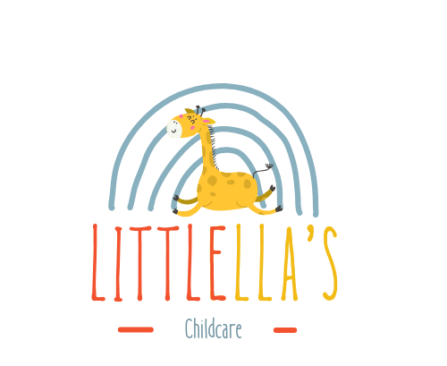

EYPP / Pupil Premium Policy
Purpose
- To ensure that additional Early Years Pupil Premium (EYPP) funding from the London Borough of Sutton is used effectively to improve outcomes for eligible children in our nursery.
- To close the gap in development (e.g., communication, social, emotional, early literacy / numeracy) between disadvantaged children and their peers.
- To set out how we identify, plan, spend, monitor, evaluate, and report on the use of EYPP.
Context and Legal Basis
- London Borough of Sutton provides EYPP funding for 9 months – 4 years. sutton.gov.uk+2Sutton Information Hub+2
- Eligibility criteria (Sutton): household income-based benefits (e.g., Income Support, Universal Credit under a threshold), or if the child has been in local authority care, adopted, or under special guardianship. Sutton Information Hub+1
- Funding is paid to providers to support learning, development, and care across the Early Years Foundation Stage (EYFS) areas. Sutton Information Hub
- According to the Sutton Early Years Funding Formula, EYPP is allocated as a fixed hourly rate per eligible child. sutton.gov.uk+1
3. Eligibility and Identification
Parental Declaration
  - On admission or at relevant termly points, we ask parents/carers to complete an EYPP Parent Declaration Form, including National Insurance (NI) number / relevant benefit information, to assess eligibility. This aligns with Sutton’s process. sutton.gov.uk+1
Verification
  - We will verify eligibility via the local authority system (or via the Department for Education’s Eligibility Checking System, as per statutory guidance). GOV.UK
  - For children under special guardianship or adopted from care, we will request relevant documentation (e.g., court order). GOV.UK
Reassessment
  - Eligibility checks should not be made more than a term in advance of funded entitlement start, to allow for changes in family circumstances. GOV.UK
  - Once a child is eligible, they remain EYPP-eligible for as long as they access the early years entitlement. GOV.UK
Use of Funding
We will use EYPP funding to support the child’s development in the following ways:
- Targeted support in personal, social and emotional development; communication and language; physical development; literacy; mathematics; understanding of the world; and expressive arts & design. Sutton Information Hub
- Smaller group work or 1:1 support for eligible children.
- Additional adult time for planning, assessment, and scaffolded interaction.
- Resources (books, play materials) that specifically support developmental areas where eligible children are lagging.
- Training for staff on pedagogical approaches (e.g., talk-based interventions, self-regulation, early mark-making).
- Parent / family engagement: workshops or communications to help parents support development at home (e.g., language stimulation, shared reading).
Budgeting and Allocation
- We will calculate the total EYPP funding based on the number of eligible children, using London Borough of Sutton’s fixed hourly rate. According to the Sutton Funding Forum
- Funds will be ring-fenced in our nursery budget to ensure transparency and accountability.
- We will plan the use of EYPP funds at least annually, but review termly (or more frequently) to adjust if needs change.
Monitoring & Evaluation
- For each eligible child, we will track developmental progress (using our usual EYFS assessment framework) in key domains (communication, PSED, literacy, numeracy).
- We will maintain a Pupil Premium / EYPP Log of interventions and spending (what was funded, how much, for whom, and why).
- Termly reviews: assess whether the interventions funded are having the desired impact; adjust strategies if necessary.
- At the end of each academic year, we will produce an EYPP Impact Report that includes:
  - Number of eligible children;
  - Summary of spend;
  - Outcomes achieved;
  - Lessons learned and planned changes for next year.
Governance
- The Nursery Manager (or Director) is responsible for overall oversight of the EYPP policy, ensuring funding is used in line with objectives.
- A Pupil Premium / EYPP Lead (member of staff) is designated to coordinate eligibility checks, parent declarations, and monitoring.
- The nursery leadership team (or governing body, if applicable) will review the EYPP policy annually.
Reporting to Parents and Stakeholders
- During parent meetings or in newsletters, we will communicate to parents how EYPP is being used for their child’s benefit.
- We will share the EYPP Impact Report with stakeholders (e.g., board, funders, local authority) to ensure transparency.
Risks and Mitigations
Risk: Low take-up / under-declaration of eligible children
- Mitigation: Proactive conversations with parents; clear, accessible parent declaration forms; confidentiality assurances; regular reminders.
Risk: Misallocation of funding / not targeting the right interventions
- Mitigation: Regular assessment, structured review meetings, logged spending, and impact tracking.
Risk: Staff not trained to deliver effective interventions
- Mitigation: Invest in professional development; share best practice; peer observation; coaching.

Policy Adoption and Review
This policy was adopted by: LittlElla’s Childcare
On: 01/11/2025
Date to be reviewed: 01/11/2026
Name and role of signatory: Samba Matundu (Nursery Manager)

