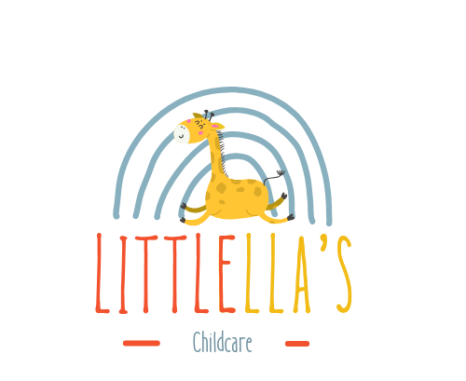

Packed Lunch Policy

For Children Aged 9 Months to 5 Years
Purpose
To ensure all children receive a balanced, nutritious meal in line with UK Government guidance for early years settings and to maintain a safe environment for children with allergies, this policy outlines the expectations for packed lunches brought into the nursery.
General Guidelines
- Packed lunches should be healthy, balanced, and support the nutritional needs of growing children.
- All packed lunches must be nut-free. We operate a strict NO NUTS policy due to life-threatening allergies.
- Meals should be manageable for young children to eat independently where appropriate.
What to Include: Parents are encouraged to provide a variety of foods from the following groups:
- Starchy Foods (Base of the meal)
  - Bread, pitta, wraps, rice cakes, pasta, or potatoes.
  - Choose wholegrain options where possible.
- Fruit and Vegetables
  - Include at least one portion of fruit and one portion of vegetables.
  - Can be fresh, frozen, or tinned (in juice not syrup).
- Protein
  - Cooked meats (chicken, turkey), fish (tuna, salmon), egg, hummus, beans or lentils.
- Dairy and Alternatives
  - Cheese, yoghurt, or plant-based alternatives with added calcium.
Optional Snacks (in moderation):
- Plain rice cakes, breadsticks, or oatcakes.
- Small portion of dried fruit.
Drinks
- Water and milk are provided by the nursery.
- Please do not include fizzy drinks, squash, or juice.
What NOT to Include:
- Nuts or nut-based products (including peanut butter, Nutella, etc.)
- Sweets or chocolate bars
- Fizzy drinks or juice drinks
- Food that requires reheating or refrigeration (unless agreed in advance)
Storage
- Packed lunches must be provided in a clearly labelled lunchbox.
- Please include an ice pack to keep food fresh as lunches may not be refrigerated.
Home-Cooked Meals
- Any home-cooked meals included in lunchboxes must be accompanied by a list of all ingredients used, especially if the dish is not in its original packaging.
- This is essential to help us manage allergy risks and ensure food safety.
Monitoring Staff will monitor the contents of lunchboxes to ensure they meet these guidelines and will discuss concerns with parents as needed.
Allergy Awareness Due to the risk to children with allergies, any lunchbox found to contain nuts will be removed and replaced with a nursery-provided alternative while parents are contacted.
Review This policy is reviewed annually in line with updates to government guidance and nursery procedures.

Policy Adoption and Review
This policy was adopted by: LittlElla’s Childcare
On: 01/01/2026
Date to be reviewed: 01/01/2027
Name and role of signatory: Samba Matundu (Nursery Manager)

